# CS 255 System Design Document Template

This template lays out all the different sections that you need to complete for Project Two. Each section has guidance to prompt your thinking. You will need to continually reference the interview transcript as you work to make sure that you are addressing your client’s needs. There is no required length for the final document. Instead the goal is to complete each section based on what your client’s needs are. Remove this note when you are finished, and replace all bracketed text with the relevant information.

## UML Diagrams

### UML Use Case Diagram

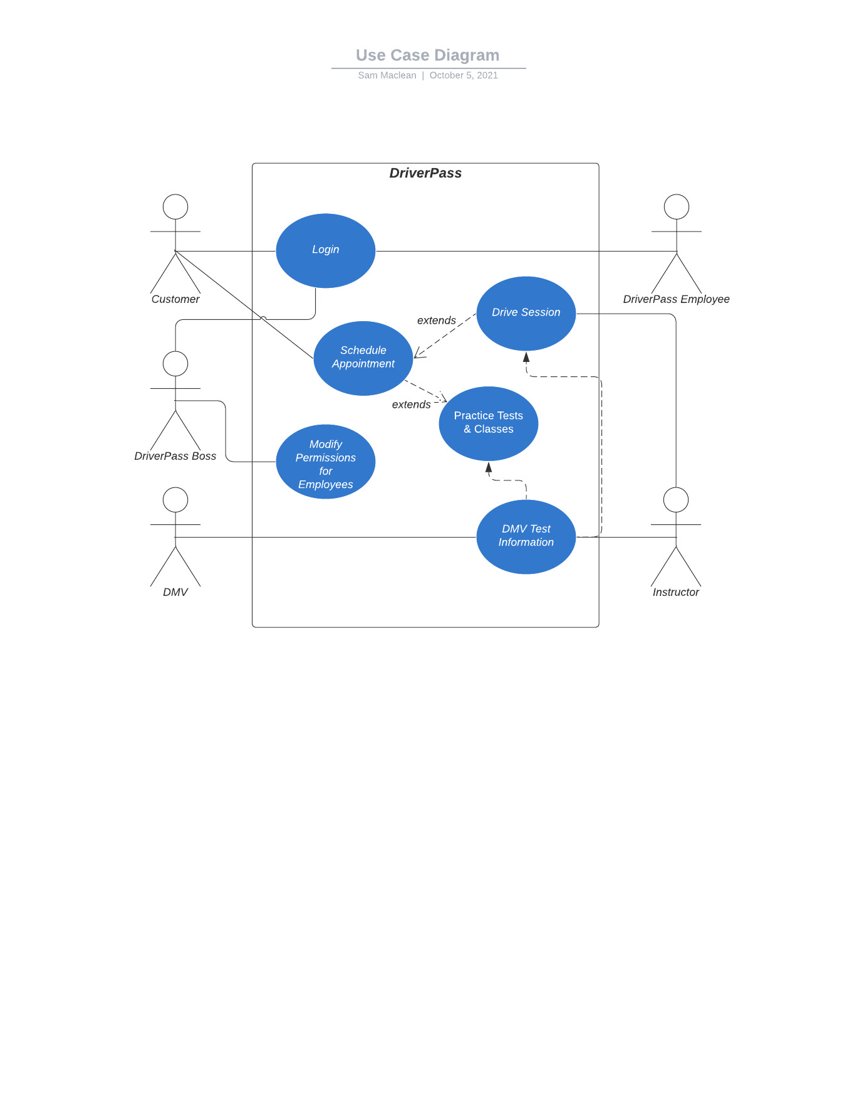

### UML Activity Diagrams

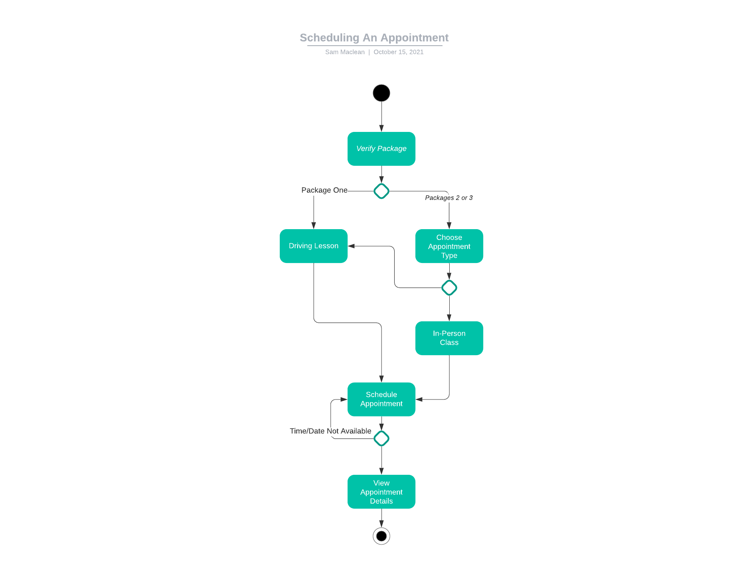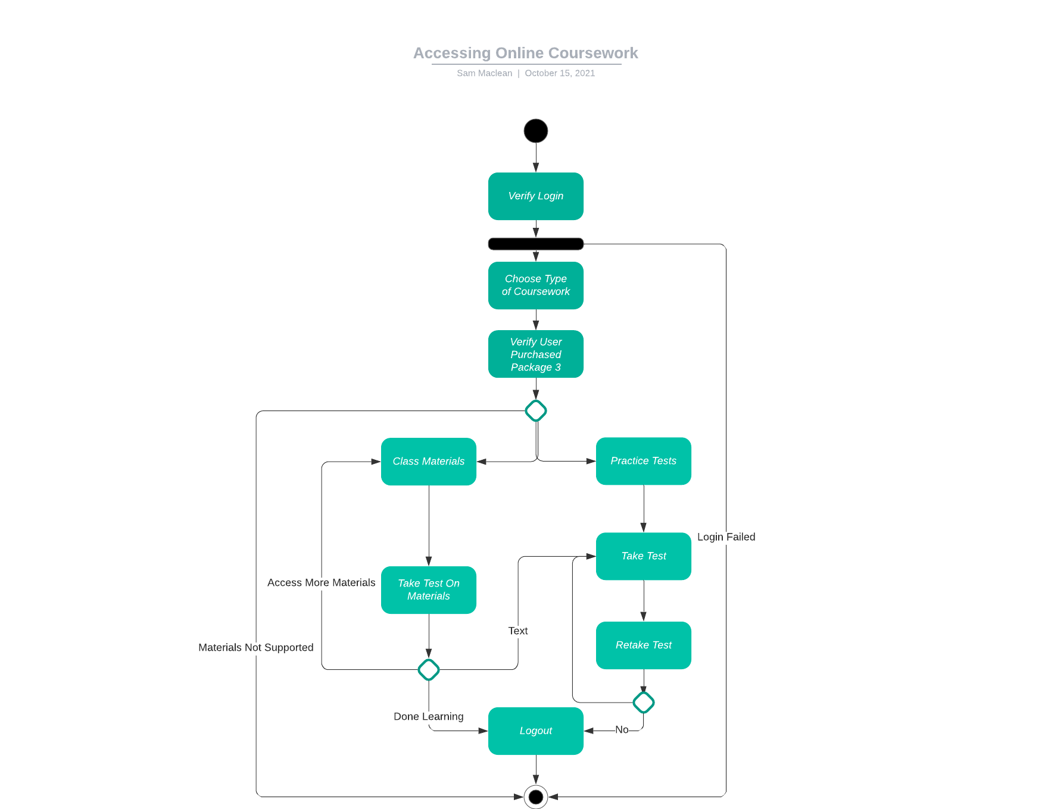

### UML Sequence Diagram

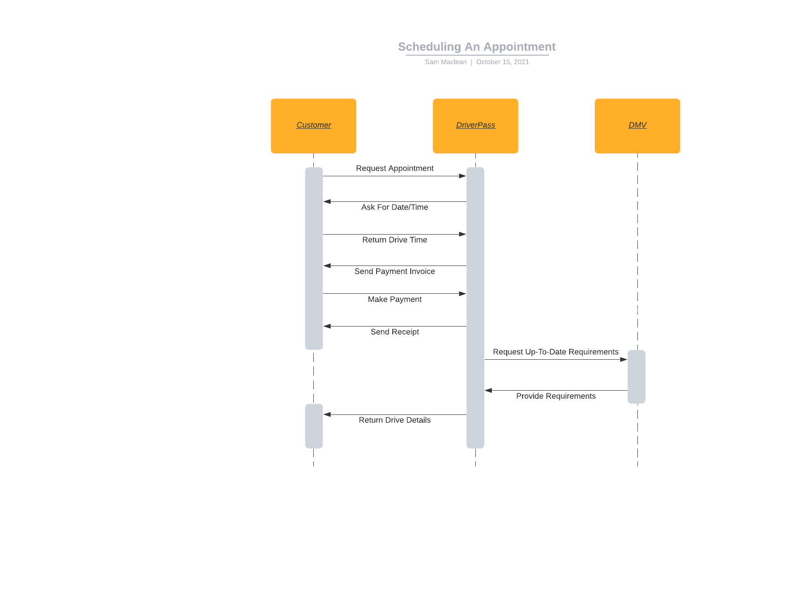

### UML Class Diagram

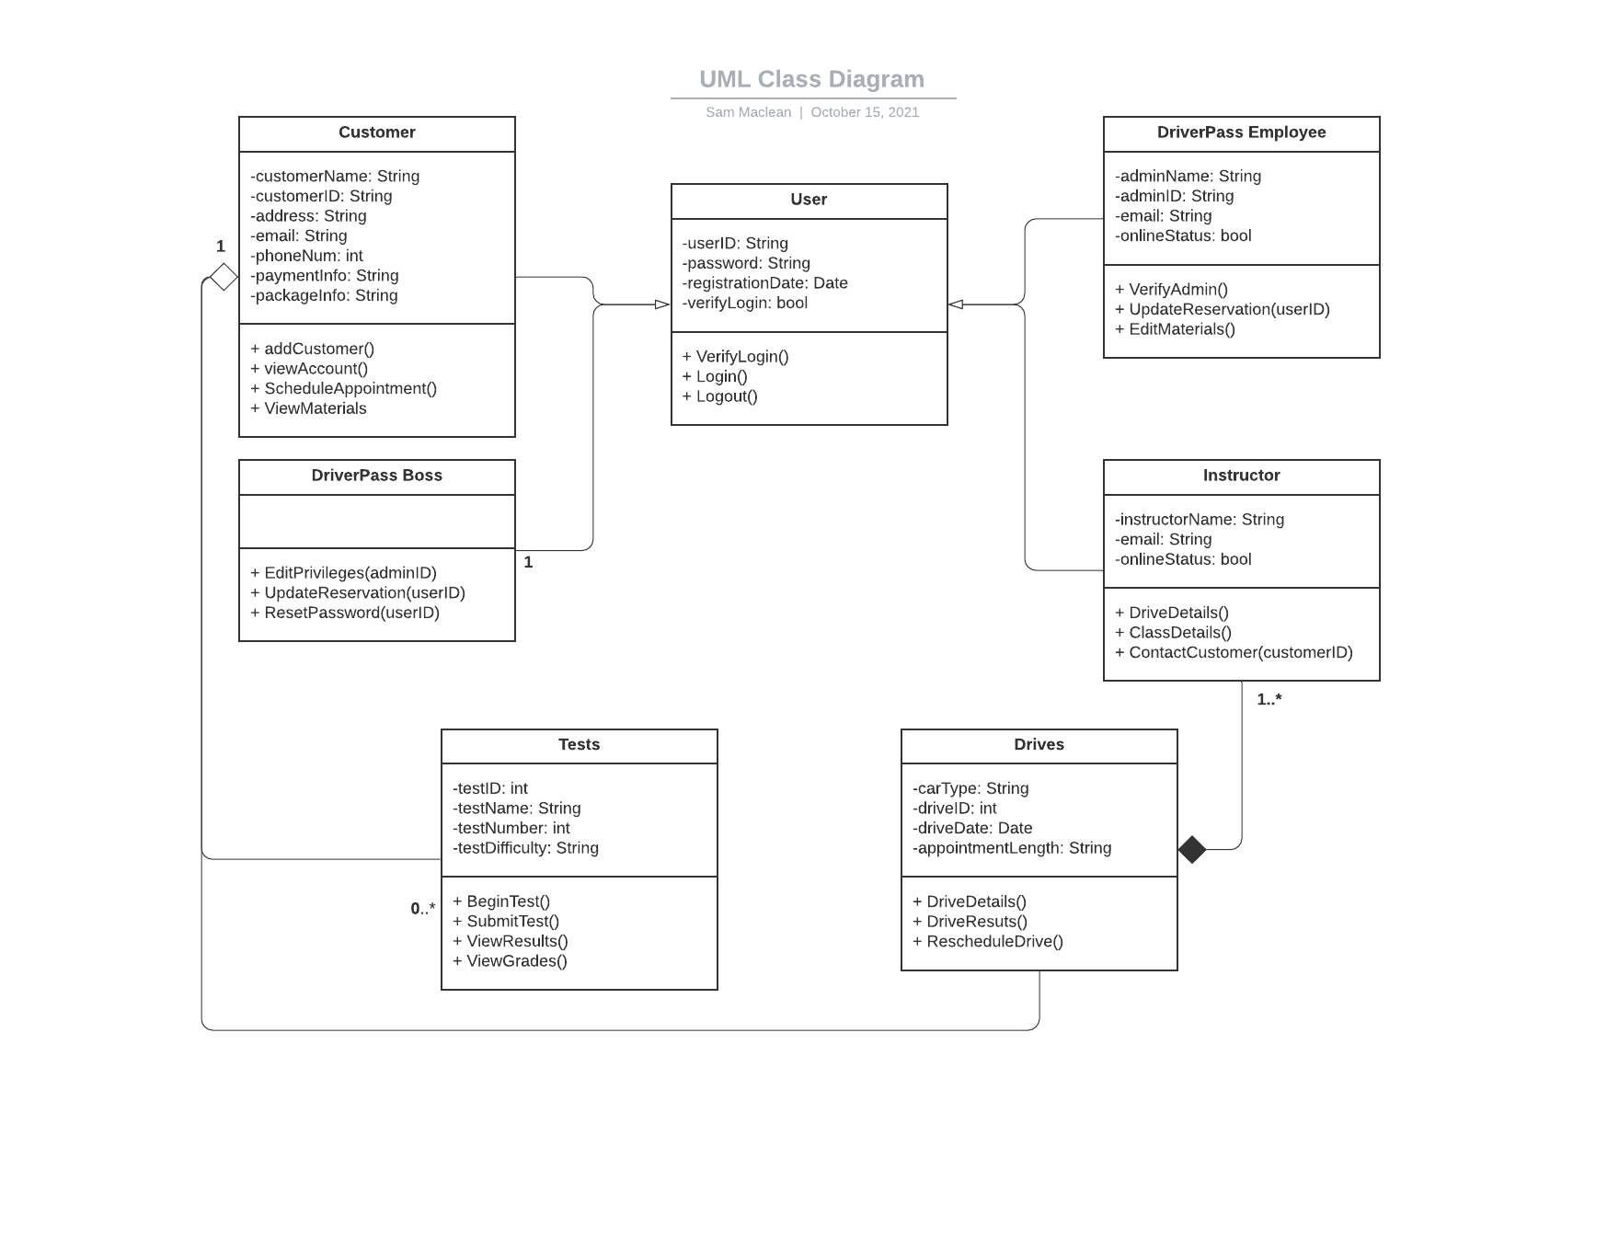

## Technical Requirements

*[Based on the diagrams you have created, describe the technical requirements of your system. These requirements should address the required hardware, software, tools, and infrastructure necessary for your system design.]*

* The system shall use IBM Spectrum Protect to safeguard data.
* The system shall use Windows computers for employees to access the website/server while in the office.
* The system shall use a cloud-based service provider to remain a cloud-based system that stores data both on hardware and in the cloud.
* The system shall use Atom to edit HTML code and create the basis for the website by use of HTML, CSS, and JavaScript.